

# A GUIDE TO THE HEALTH

CANADA APPLICATION

PROCESS

## For clinical trials initiated at The Royal’s Institute of

Mental Health Research

Summary

Detailed guidance on the process of submitting applications to Health Canada for approval to conduct clinical trials using pharmaceuticals, natural and non-prescription health products,

biologics, radiopharmaceuticals and medical devices

### Prepared by Tammy Beaudoin, Clinical Research Support Manager

[Tammy.beaudoin@theroyal.ca](mailto:Tammy.beaudoin@theroyal.ca)

Health Canada is the regulatory body that oversees the use of the following;



Health Canada

Oversight

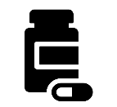

**Therapeutic Products (Pharmaceutical Drugs)**



**Non-Prescription & Natural Health Products –**

supplements, vitamins, herbal remedies, minerals



**Radiopharmaceuticals –** molecular imaging probes, contrast agents or tracers (i.e. fluorine, gallium)



**Biologics & Genetic Therapies –** cells, vaccines, gene therapies, blood & blood products (i.e. immunoglobulin)



**Medical Devices (Class II, III or IV) –** pacemakers, orthopedic devices, device software

##### *A Health Canada Clinical Trial Application (CTA) is required when a drug (pharmaceutical and/or biologic and* radiopharmaceutical) or natural health product:

* Has not been approved by Health Canada or is in its development stages (Phase I-III)
* Is approved but is being used for a new indication or a new clinical use
* Is approved but is being used for a different target population
* Is approved but is using an alternate route of administration
* Is using a dosage outside of the marketed approved dose regimen Note:
* Observational trials and phase IV trials are not subject to Health Canada CTA process. Phase IV trials are trials involving marketed drugs where the investigation is to be conducted within the parameters of its marketing approval (notice of compliance (NOC)/drug identification number (DIN)).

##### *A Health Canada Application for Investigational Testing Authorization (ITA) is required for:*

* Class II, III, IV medical devices

Note:

Class I medical devices are not subject to a HC application for ITA.

For additional information related to Investigational Testing Authorization (ITA) for medical devices, please refer to [N2](http://oreo.rohcg.on.ca/departments/imhr/documents/024ITAforMedicalDevices.pdf) [SOP 024 ITA for Medical Devices](http://oreo.rohcg.on.ca/departments/imhr/documents/024ITAforMedicalDevices.pdf)

* + A protocol that is to be submitted to Health Canada for review/approval must be formatted according to section 6 of the **International Council for Harmonisation Good Clinical Practice (GCP)** guidelines to meet Health Canada requirements.



Protocol

**Useful Links/Resources:**

* + - [ICH/GCP Good Clinical Practice Guidelines](https://www.canada.ca/en/health-canada/services/drugs-health-products/drug-products/applications-submissions/guidance-documents/international-conference-harmonisation/efficacy/good-clinical-practice-consolidated-guideline-topic.html)
    - [SPIRIT Checklist](http://oreo.rohcg.on.ca/departments/imhr/Resources-ResearchEthicsBoard.cfm)
  + Health Canada provides guidance on the application process and the specific requirements for drug, NHP and medical device applications.



Health Canada Guidance

* + Pharmaceutical drugs are reviewed by the Therapeutic Directorate Branch (TPD)
  + Biologic and radiopharmaceutical drugs are usually reviewed by the Biologics and Genetic Therapies Directorate(BGTD)
  + Natural health product applications are reviewed by the Natural and Non- Prescriptions Health Products Directorate (NNHPD).
  + A combination of a pharmaceutical and a NHP will be reviewed by the TPD.
  + Applications for ITAs (devices) are reviewed by the Medical Device Bureau of the TPD.

#### Useful Links/Resources:

* + - [Guidance Document for Clinical Trial Sponsors: Clinical Trial Applications](https://www.canada.ca/en/health-canada/services/drugs-health-products/drug-products/applications-submissions/guidance-documents/clinical-trials/clinical-trial-sponsors-applications.html)
    - [Health Canada CTA Electronic Submission Format Guidelines](https://www.canada.ca/en/health-canada/services/drugs-health-products/drug-products/applications-submissions/guidance-documents/common-technical-document/updated-guidance-document-preparation-regulatory-activities-non-ectd-electronic-only-format.html)
    - [Guidance Document for Non-Prescription and Natural Health Product Trials](https://www.canada.ca/en/health-canada/services/drugs-health-products/natural-non-prescription/legislation-guidelines/guidance-documents/clinical-trials.html)
    - [A Guide for the Preparation of Applications for Authorization of Positron- Emitting Radiopharmaceuticals for use in Basic Clinical Research Studies](https://www.canada.ca/content/dam/hc-sc/migration/hc-sc/dhp-mps/alt_formats/pdf/brgtherap/applic-demande/guides/radiopharm/pers_guide_ligne_prep-eng.pdf)
    - [Applications for Medical Device Investigational Testing Authorizations Guidance Document](https://www.canada.ca/en/health-canada/services/drugs-health-products/medical-devices/application-information/guidance-documents/investigational-testing-authorizations-guidance/guidance-document.html)

All Clinical Trial Applications (CTAs) must be submitted in the proper format to [tammy.beaudoin@theroyal.ca](mailto:tammy.beaudoin@theroyal.ca) prior to submitting the application to Health Canada. During this review, the application will be assessed for accuracy, completeness and compliance with ICH-GCP and Health Canada requirements. The reviewer will communicate with your team any items that need to be addressed prior to submitting the CTA.

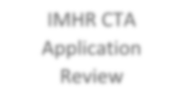

IMHR CTA

Application Review

To avoid multiple back and forth revisions with the Facilitator:

* + - Utilize a GCP/HC compliant protocol template
    - Follow instructions in the appropriate HC guidance documents closely
    - Complete the CTA review checklist prior to submission
    - Submit the application in the HC required file structure i.e. Zip folder
  + Once the CTA is deemed complete and accurate, the IMHR’s Chief Operating Officer will be notifed that the Health Canada 3011 form is ready to be signed off. The 3011 forms must arrive at the COO’s office already signed by the investigator. When signatures are complete the application may be submitted to Health Canada.

#### Useful Links/Resources:

* + - [N2 SOP 018 Clinical Trial Application Drugs](http://oreo.rohcg.on.ca/departments/imhr/documents/018CTADrugs.pdf)
    - [N2 SOP Clinical Trial Application Natural Health Products](http://oreo.rohcg.on.ca/departments/imhr/documents/023CTANaturalHealthProducts.pdf)
    - [Investigational Testing Authorization (ITA) for Medical Devices (non-IVDD) and Manufacturer/Sponsor Obligations](http://oreo.rohcg.on.ca/departments/imhr/documents/024ITAforMedicalDevices.pdf)



***Drugs (pharmaceuticals) and/or Biologics***

* Clinical Trial Applications (CTAs) and CTA-Amendments (CTA-As) made to the Therapeutic Products Directorate (TPD) must be submitted electronically. ***Hard copy applications are no longer accepted***.
* When submitting a CTA or CTA-A, you must include a hard copy of the ***cover letter only***. This will accompany the CD.
* Section 2.1 of the electronic submission guidance document outlines specific requirements that must be included in the cover letter.
* Documents that require a signature (e.g. Form 3011, cover letter, attestation) should be printed, signed, scanned and saved as PDF files unless otherwise instructed.
* Acceptable folder structure for CTAs can be found in the regulations
* Empty folders should not be included in the structure (delete) however, the folder numbering should not be modified
* The Clinical Trial Site Information (CTSI) form should be submitted ***only*** after all approvals have been obtained, training is complete and the study is ready to begin recruitment.
* The Qualified Investigator Undertaking (QIU) form must be signed by each site’s Qualified Investigator, must remain in the regulatory binder at the site and is ***not*** submitted to Health Canada unless requested.
* Health Canada will complete the review process within 30 days of receipt of the application. Upon approval, a No Objection Letter (NOL) will be issued to the sponsor. **If an NOL is not received after 30 days do not start the study. Contact Health Canada to follow-up.**
* Requests by Health Canada for clarification related to the application ***must*** be responded to within 2 calendar days.
* For all biologics, the BGTD requires that the lot release information be provided by the CTA sponsor/manufacturer before its use in the trial.
* Trials receiving approval by the TPD & BGTD must follow GCP guidelines and Division 5 Food & Drug regulations.
* Only ***serious, unexpected, adverse drug reactions*** should be reported to Health Canada as per Health Canada Division 5 regulations for trials conducted under a NOL.

#### Sequencing of Applications

Clinical Trial Applications may be submitted to the TPD/BGTD;

* + **Prior to obtaining REB approval** – this is most common when trials are complex in nature or require pre- CTA review/consultation.
  + **Post REB approval –** this process is usually followed when protocols are straight forward and pre-CTA review is not required by Health Canada. As the REB review process can take longer than 30 days, research teams often prefer to obtain REB approval first, then submit to Health Canada for approval within the 30-day review period. Obtaining REB approval first will eliminate the need for a potential CTA-A to HC due to changes requested by REB.
  + **Simultaneously with the REB application** – while both reviews can occur at the same time, any requested changes to the protocol or trial information will have to be amended and submitted to both parties which can lead to numerous document versions and can be confusing at the time of HC inspection.

##### *For assistance determining the best process for your trial, please contact IMHR Administration to discuss.*



***Natural & Non-Prescription Health Products***

* [NNHPD Clinical Trial Application Forms](https://www.canada.ca/en/health-canada/services/drugs-health-products/natural-non-prescription/legislation-guidelines/guidance-documents/clinical-trials.html#a3a) differ from those submitted to the TPD for drug trials. When preparing a submission, it is important to ensure the correct forms are being used.
* The CTA must be submitted in the Common Technical Document (CTD) format. It must be submitted in hard copy. As per the guidance document, selected items must also be submitted in electronic format as well.
* Two hard copies and two electronic copies must be submitted.
* **REB approval** must be submitted to the NNHPD with the application.
* A completed CTSI & QIU form must be submitted ***with*** the application. If the information required to complete these forms is not available at the time of application, they must be submitted prior to commencement of the trial at the site. Maintain a copy with the study file.
* If a NHP/Pharmaceutical combination is being used and the pharmaceutical product is being used outside of its marketing approval, the CTA must be submitted to the **Therapeutic Products Directorate (TPD)** and not the NNHPD.
* If a NHP contains a medicinal ingredient that requires a prescription, then the CTA must be submitted to the

**Therapeutic Products Directorate (TPD)** and not the NNHPD.

* Requests by Health Canada for clarification related to the application should be responded to within 30 days.
* A Notice of Authorization (NOA) will be issued to the sponsor upon approval of the application.
* Unlike drug trials, for studies conducted under a NOA using non-prescription and/or natural health products, **all *serious, unexpected and expected, adverse drug reactions*** should be reported to Health Canada as per Health Canada Natural Health Products regulations. If expected SADRS are not going to be collected and reported, the protocol must indicate and justify this. Expected SADRs are listed in the product monograph/investigator brochure.



***Radiopharmaceutical & Medical Device Trials***

* For guidance related to trials in which radiopharmaceuticals or medical devices will be used, please contact the Clinical Research Support Manager for guidance.



Good to Know

* + ***Health Canada Pre-CTA Consultation Process:*** Health Canada encourages sponsors to request a pre-CTA consultation meeting when new active substances will be investigated or when applications will be submitted that include complex issues that may be new to Health Canada (e.g. involving stem cells). This process allows the sponsor to present important information, and discuss any concerns and/or issues prior to submitting an application. Guidance for requesting a Pre-CTA Consultation meeting can be found [here.](https://www.canada.ca/en/health-canada/services/drugs-health-products/drug-products/applications-submissions/guidance-documents/clinical-trials/pre-clinical-trial-application.html) It is important to engage IMHR Administration in these meetings.

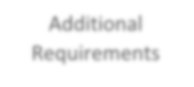

Additional Requirements

* ***Publication Requirements:*** Research staff must be familiar with best practices in publishing. This helps ensure research papers meet quality reporting standards. Authorship guidelines and knowledge of best publication practices must be considered at the outset of a clinical research study/trial.
* ***Data Safety Monitoring Board (DSMB):*** All interventional research must be assessed for the need for a DSMB. Safety monitoring is the responsibility of a clinical trial sponsor (lead investigator).
* ***Trial Monitoring:*** As per GCP section 5.18, it is a sponsor responsibility to ensure that trials are adequately monitored. A monitoring plan must be developed and submitted to the Clinical Research Support Manager for review and approval.
* ***Trial Registration:*** To comply with the Tri-Council Policy Statement (TCPS), all clinical trials must be registered in a public registry that is acceptable to the World Health Organization (WHO) or the International Committee of Medical Journal Editors (ICMJE).

The following diagram outlines the process to be followed when conducting an IMHR sponsored, investigator-initiated, Health Canada regulated clinical trial.



CTA Process

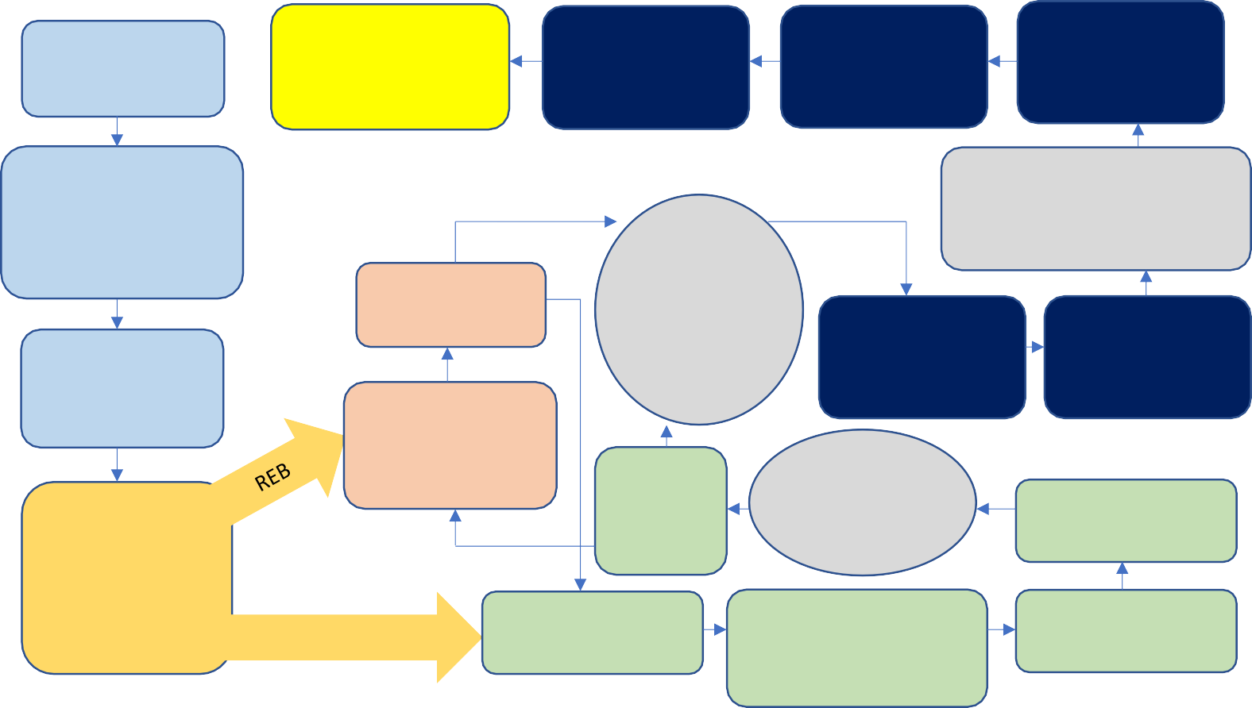

Secure Funding

Study may open to

recruitment

Submit CTSI to

Health Canada

Site Activation

Investigator

Agreement Meeting

Pre-CTA

consultation meeting if applicable

Contact Clinical Research

Support Manager to review sponsor responsibilities

Obtain REB

approval

Develop GCP

Compliant protocol & ICF

**REB & HC**

**Approvals Obtained & Contracts Final**

Ensure all

training is complete

Delegation of

tasks

Submit REB

application for review

Determine if

submitting to REB or HC first or simultaneously

Receive

HC

Approval

**HC 30 Day**

**Review Period**

Submit to Health

Canada

Health Canada

Prepare Clinical

Trial Application

Submit CTA to

Administration for Review

Obtain Signatures

upon approval

For additional assistance, please contact Tammy Beaudoin

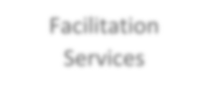

Facilitation Services

#### Tammy Beaudoin

**Email:** [tammy.beaudoin@theroyal.ca](mailto:tammy.beaudoin@theroyal.ca)

**Phone:** 613-722-6521

Ext. 6214